 | PHYSICS 2AB: MOVEMENT  LAB VALIDATION | Name:
 | PHYSICS 2AB: MOVEMENT  LAB VALIDATION | MARKS / 17

Part 1
Acceleration of free falling bodies – varying height

In a project designed to measure the acceleration due to gravity at the surface of the Earth, two students, Sam and Riley, drop a basketball from rest from various heights and measure the time taken to fall.

Their hypothesis is: “the time taken to fall will be proportional to the height from which the ball is dropped”.

- By making appropriate substitutions for any known values and rearranging the equation s = ut + ½ at² to show their hypothesis is unlikely. (1 mark)

t =

- State an alternative hypothesis, as suggested by your equation in (1) (1 mark)

2. The students use a balcony, a measuring tape, and an electronically triggered stop watch to measure the following results. Use the equation you derived above to complete the final column: (2 marks)

Height (m) | Measured time to fall (s) |  |  | Mean time to fall (s) | Theoretical time to fall (s)
Height (m) | Trial 1 | Trial 2 | Trial 3 | Mean time to fall (s) | Theoretical time to fall (s)
1 | 0.44 | 0.45 | 0.44 | 0.44 | 0.45
2 | 0.65 | 0.65 | 0.67 | 0.66 | 0.64
3 | 0.82 | 0.81 | 0.82 | 0.82 | 0.78
4 | 0.95 | 0.95 | 0.96 | 0.95
5 | 1.09 | 1.10 | 1.10 | 1.10
6 | 1.22 | 1.21 | 1.22 | 1.22
- The measured data is plotted below. Connect the data points with a sketched curve.
(1 mark).

Plot the data for the theoretical time to fall on the same graph. Again connect the data with a sketched curve and clearly label each curve. (2 marks)

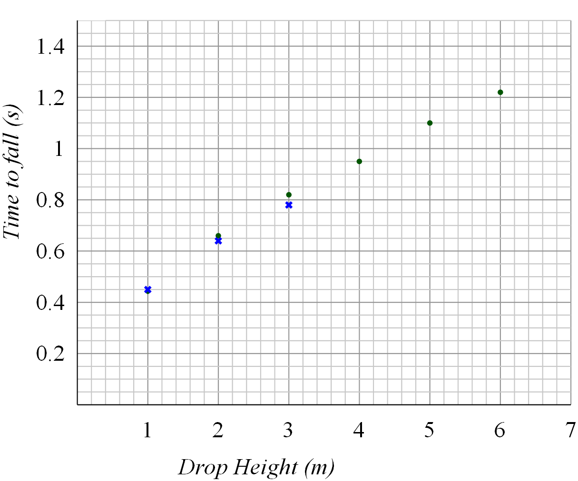

4. Sam notices that the curves get further and further apart as the height increases. He proposes that this ‘error’ is due to ‘human limitations’ when trying to let go of the ball the same way each time.

- Explain why this is probably not the reason for the difference in the curves (1 mark)

- Suggest an alternative reason for this ‘error’ (1 mark)

- How could the experiment be improved to reduce the effect of the ‘error’ you suggested in (b). (1 mark)

Part 2

Acceleration - varying force

In STAWA Exploring Physics experiment 3.1 a trolley was accelerated by the weight of a mass hanging in a cradle. The mass in the cradle was varied in order to vary the accelerating force, though the total accelerated mass was kept constant. Time for the trolley to travel a given distance was measured, and this was used to calculate the acceleration of the trolley.

1. For a trolley starting at rest, once again rearrange the equation s = ut + ½ at² , this time making acceleration ‘a’ the subject: (1 mark)

a =

The following data was collected by a group carrying out the experiment. The acceleration has already been calculated.

Total mass of cradle (kg) | Accelerating force (N) | Measured time to fall (s) |  |  | Distance travelled by trolley (m) | Calculated acceleration  (m / s²)
Total mass of cradle (kg) | Accelerating force (N) | Trial 1 | Trial 2 | Mean time (s) | Distance travelled by trolley (m) | Calculated acceleration  (m / s²)
0.0131  0.0231  0.0331  0.0431  0.0531  0.0631  0.0731 | 0.13  0.23  0.32  0.42  0.52  0.62  0.72 | 4.3  2.9  2.4  2.0  1.8  1.7  1.7 | 4.1  2.9  2.6  2.1  1.8  1.8  1.5 | 4.2  2.9  2.5  2.0  1.8  1.7  1.6 | 1.2  1.2  1.2  1.2  1.2  1.2  1.2 | 0.14  0.29  0.38  0.60  0.74  0.83  0.94

2. Plot accelerating force against acceleration and draw a line of best fit (although force is the independent variable, in this case it should be plotted on the y-axis). (3 marks)



3. Using the line of best fit, calculate the total mass of the trolley system (trolley + cradle + masses). Show all working in your calculation. (3 marks)

 | PHYSICS 2AB: MOVEMENT  LAB VALIDATION | Name: SOLUTIONS
 | PHYSICS 2AB: MOVEMENT  LAB VALIDATION | MARKS / 16

Part 1
Acceleration of free falling bodies – varying height

In a project designed to measure the acceleration due to gravity at the surface of the Earth, two students, Sam and Riley, drop a basketball from rest from various heights and measure the time taken to fall.

Their hypothesis is: “the time taken to fall will be proportional to the height from which the ball is dropped”.

- By making appropriate substitutions for any known values and rearranging the equation s = ut + ½ at² to show their hypothesis is unlikely. (1 mark)

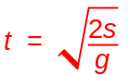

- State an alternative hypothesis, as suggested by your equation in (1 mark)

time taken to fall will be proportional to the square root of distance.

2. The students use a balcony, a measuring tape, and an electronically triggered stop watch to measure the following results. Use the equation you derived above to complete the final column (2 marks):

Height (m) | Measured time to fall (s) |  |  | Mean time to fall (s) | Theoretical time to fall (s)
Height (m) | Trial 1 | Trial 2 | Trial 3 | Mean time to fall (s) | Theoretical time to fall (s)
1  2  3  4  5  6 | 0.44  0.65  0.82  0.95  1.09  1.22 | 0.46  0.65  0.81  0.95  1.10  1.21 | 0.45  0.67  0.82  0.96  1.10  1.22 | 0.45  0.66  0.82  0.95  1.10  1.22 | 0.45  0.64  0.78  0.90  1.01  1.11

- The measured data is plotted below. Connect the data points with a sketched curve. (1 mark).

Plot the data for the theoretical time to fall on the same graph. Again connect the data with a sketched curve and clearly label each curve. (1 mark)

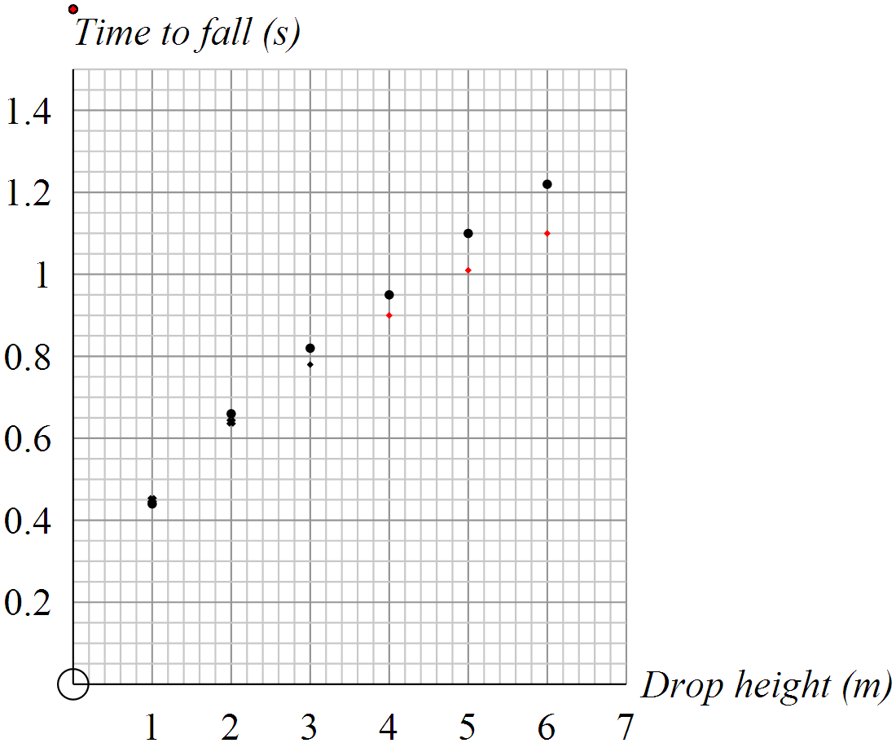

Curves continue to (0,0) : ✓
Second curve is accurately plotted. ✓

4. Sam notices that the curves get further and further apart as the height increases. He proposes that this ‘error’ is due to ‘human limitations’ when trying to let go of the ball the same way each time.

- Explain why this is probably not the reason for the difference in the curves (1 mark)

The discrepancy is clearly not random or, the discrepancy shows a consistently increasing trend, or there is very little discrepancy at low values of s, or similar

- Suggest an alternative reason for this ‘error’ (1 mark)

Drag / air resistance.

- How could the experiment be improved to reduce the effect of the ‘error’ you suggested in (b). (1 mark)

Use a smaller ball

Part 2

Acceleration - varying force

In experiment 3.1, a trolley was accelerated by the weight of a mass hanging in a cradle. The mass in the cradle was varied in order to vary the accelerating force. Time for the trolley to travel a given distance was measured, and this was used to calculate the acceleration of the trolley.

1. For a trolley starting at rest, once again rearrange the equation s = ut + ½ at² , this time making acceleration ‘a’ the subject: (1 mark)

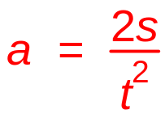

2. The following data was collected by a group carrying out experiment 3.1. The acceleration has already been calculated.

Total mass of cradle (kg) | Accelerating force (N) | Measured time to fall (s) |  |  | Distance travelled by trolley (m) | Calculated acceleration  (m / s²)
Total mass of cradle (kg) | Accelerating force (N) | Trial 1 | Trial 2 | Mean time (s) | Distance travelled by trolley (m) | Calculated acceleration  (m / s²)
0.0131  0.0231  0.0331  0.0431  0.0531  0.0631  0.0731  0.0831 | 0.13  0.23  0.32  0.42  0.52  0.62  0.72  0.81 | 4.3  2.9  2.4  2.0  1.8  1.7  1.7  1.5 | 4.1  2.9  2.6  2.1  1.8  1.8  1.5  1.5 | 4.2  2.9  2.5  2.0  1.8  1.7  1.6  1.5 | 1.2  1.2  1.2  1.2  1.2  1.2  1.2  1.2 | 0.14  0.29  0.38  0.60  0.74  0.83  0.94  1.07

Plot accelerating force against acceleration a draw a line of best fit (although force is the independent variable, in this case is should be plotted on the y-axis). (3 marks)

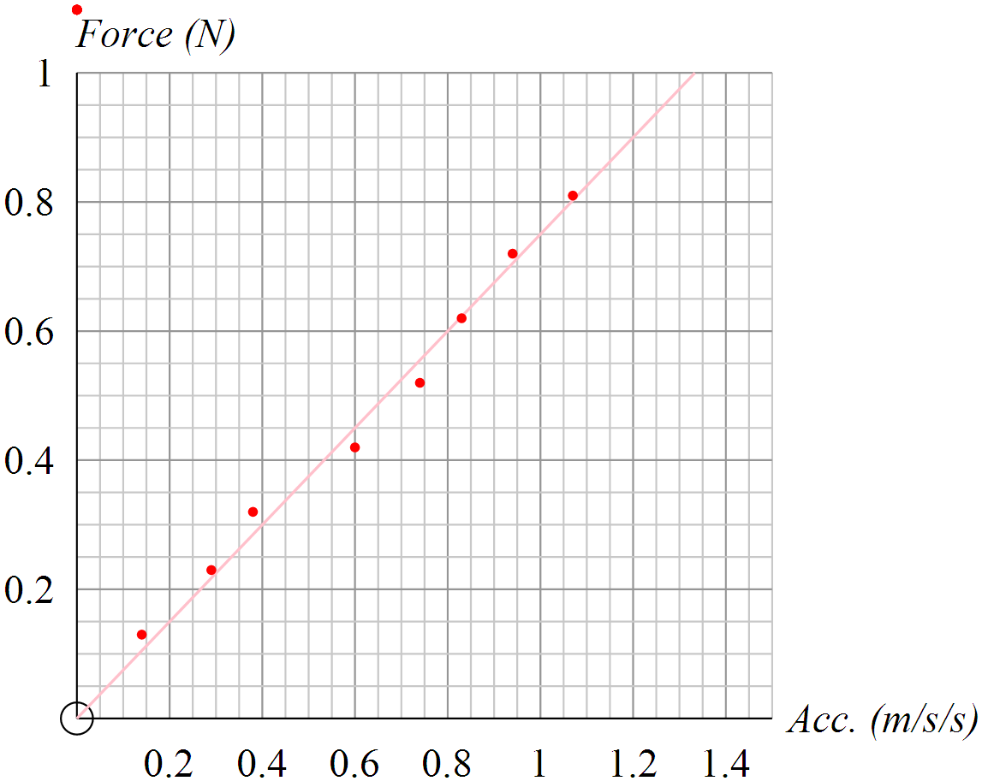

3. Using the line of best fit, calculate the total mass of the trolley system (trolley + cradle + masses). Show all working in your calculation. (3 marks)

m = (0.75 – 0.3) / (1 – 0.4) = 0.75 kg

Accurately plotted ✓
Axes labelled with units ✓
Line of best fit is reasonable. ✓
Shows how gradient is determined ✓
Calculates gradient correctly (either m = f/a or 1/m = a/f) ✓
Obtains close to ** kg for mass of trolley ✓

